INNOVA JUNIOR COLLEGE
JC 2 PRELIMINARY EXAMINATION 2
in preparation for General Certificate of Education Advanced Level
Higher 2

CANDIDATE
NAME

CLASS INDEX NUMBER

CHEMISTRY  Paper 2 Structured  Candidates answer on the Question Paper.  Additional Materials: Data Booklet | 9647/02  20 September 2010  2 hours

READ THESE INSTRUCTIONS FIRST

Write your index number, name and civics group on all the work you hand in.
Write in dark blue or black pen.
You may use pencil for any diagrams, graphs or rough working.
For Examiner’s Use
1 | 12
2 | 14
3 | 10
4 | 13
5 | 12
6 | 11
Total | 72

Do not use staples, paper clips, highlighters, glue or correction fluid.

Answer all questions in the space provided.
A Data Booklet is provided.

You are advised to show all working in calculations.
You are reminded of the need for good English and clear presentation in your answers.
You are reminded of the need for good handwriting.
Your final answers should be in 3 significant figures.

You may use a calculator.

The number of marks is given in brackets [ ]
at the end of each question or part question.

At the end of the examination, fasten all your work securely together.

You are advised to spend 30 minutes for Planning Q1.

This document consists of 20 printed pages and 2 blank pages.

 | Innova Junior College | [Turn over

Answer ALL questions on the space provided.

1 | Planning (P)  Iron(II) sulfate and ammonium sulfate combine to form the double salt, iron(II) ammonium sulfate, FeSO₄.(NH₄)₂SO₄.xH₂O.
 | (a) | Describe how a titration method involving Fe²⁺ may be used to determine the value of x in a sample of FeSO₄.(NH₄)₂SO₄.xH₂O (details of calculations are not required). You may assume all the apparatus used are clean and dry.
……..……………………………………………………………………….…………………..

……..……………………………………………………………………….…………………..

……..……………………………………………………………………….…………………..

……..……………………………………………………………………….…………………..

……..……………………………………………………………………….…………………..

……..……………………………………………………………………….…………………..

……..……………………………………………………………………….…………………..

……..……………………………………………………………………….…………………..

……..……………………………………………………………………….…………………..

……..……………………………………………………………………….…………………..

……..……………………………………………………………………….…………………..

……..……………………………………………………………………….…………………..
 | [4]
 | (b) | (i) | Write an overall ionic equation for the above titration.
 |  |  | ……………………………………………………………………….…………………..
 |  | (ii) | An excess of sodium hydroxide solution was added to the titration flask after the titration was complete. Write two equations with state symbols for the reactions taking place.
……………………………………………………………………….…………………..

……………………………………………………………………….…………………..

 |  | (iii) | State and explain whether a back titration method using aqueous NaOH would be suitable in determining the value of x in the double salt.
……………………………………………………………………….…………………..

……………………………………………………………………….…………………..

……………………………………………………………………….…………………..
 |  |  | [4]
 | (c) | An impure sample of FeSO₄.(NH₄)₂SO₄.xH₂O was contaminated with sulfite ions, SO₃²⁻. Describe one test to distinguish between sulfite and sulfate ions.
Test: …………………………………………………………………………………….……

…………………………………………………………………………………………………

Observation: …………………………………………………………………………………

…………………………………………………………………………………………………

…………………………………………………………………………………………………

 |  | [4]
 |  | [Total: 12]

BLANK PAGE

2 | (a) | The solubility product values of some Group II carbonates, at 25 °C, are given in the table below:
  Group II carbonates | K_{sp}/ mol² dm⁻⁶
  MgCO₃ | 6.82 x 10⁻⁶
  CaCO₃ | 3.36 x 10⁻⁹
  SrCO₃ | 5.60 x 10⁻¹⁰
 |  | (i) | Identify the most soluble carbonate listed above and write an expression for its solubility product, K_{sp}.
 |  |  | ……………………………………………………………………………………………
 |  | (ii) | Calculate the solubility, in mol dm⁻³, of the most soluble carbonate identified in (a)(i).
 |  | (iii) | Solution Q contains 0.0100 mol dm⁻³ magnesium chloride and 0.0100 mol dm⁻³ strontium chloride.  Predict and explain, with the aid of calculations, what would happen when equal volumes of solution Q and 5 x 10⁻⁴ mol dm⁻³ sodium carbonate are mixed together.
 |  |  | [5]
 | (b) | MgCO₃ and FeCO₃ undergo thermal decomposition to release carbon dioxide at high temperatures.
 |  | (i) | Using suitable data from the Data Booklet, predict and explain the decomposition temperature of FeCO₃, given that MgCO₃ decomposes at 250 °C.
……………………………………………………………………….…………………..

……………………………………………………………………….…………………..

……………………………………………………………………….…………………..

……………………………………………………………………….…………………..

……………………………………………………………………….…………………..
 |  | (ii) | The graph in Fig. 2.1 shows the change in mass that occurs when 1.0 g of powdered magnesium carbonate, MgCO₃ is heated at T ºC where t is the time when the mass of its residue is stabilised.  Sketch, on the same axes below, the variation in mass of residue when 1.0 g of powdered iron carbonate, FeCO₃ is heated at T ºC.
 |  |  | 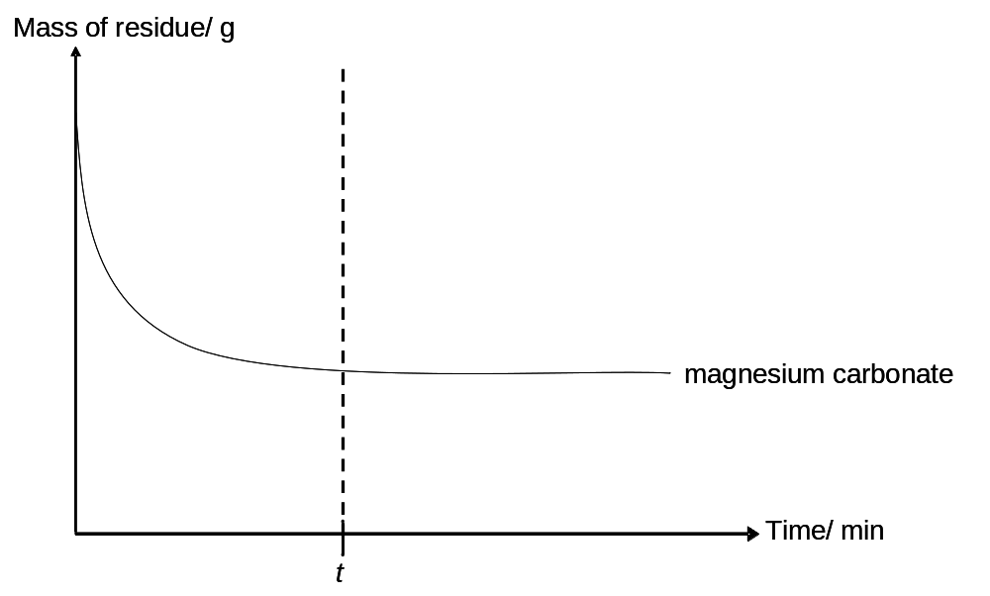
 |  |  | Fig. 2.1
 |  |  | [4]
 | (c) | (i) | Draw a labelled diagram to show how you would determine the standard electrode potential of the Cr₂O₇²⁻(aq)/ Cr³⁺(aq) electrode system.
 |  | (ii) | By considering E^{θ} values, suggest one possible reaction that would occur when aqueous acidified Na₂Cr₂O₇ is added to VOSO₄.
 |  |  | [5]
 |  |  | [Total: 14]
3 | (a) | Ionic compounds consist of cation(s) whose total positive charge is balanced by the negative charge of anions. A new class of compounds called electrides has been synthesised, with ‘trapped’ and localised electrons taking on the role of anions.  Electrides have the general formula M⁺(L)_{n}e⁻, in which e⁻ represents the trapped electron, M⁺ is an alkali metal cation and L is an organic molecule that binds the cation in a ‘cage’.  The electride Cs⁺(C222)e⁻(s) is formed from the alkali metal Cs and the organic molecule C222. The equation representing the enthalpy change of formation of Cs⁺(C222)e⁻(s) is shown below:  C222(s) + Cs(s) Cs⁺(C222)e⁻(s)  Using the data tabulated below, construct a Born-Haber cycle and calculate a value for the enthalpy change of formation of Cs⁺(C222)e⁻(s).
  Enthalpy term | ∆H^{θ} / kJ mol⁻¹
  Cs(s) Cs(g) | +76.6
  Cs(g) Cs⁺(g) + e⁻ | +378.1
  C222(s) C222(g) | +54.3
  Cs⁺(g) + C222(g) Cs⁺ C222(g) | –276.5
  Cs⁺(C222)(g) + e⁻ Cs⁺(C222) e⁻(s) | –292.3
 |  |  | [3]
 | (b) | The diagram below shows the structure, at pH 7, of a fragment from a protein which contains four amino acids, R, S, T, and U.  R S T U  ─NHCHCONHCHCONHCHCONHCHCO─  │ │ │ │ CH₂SH COOH CH₂NH₂ CH(CH₃)₂
 |  | (i) | Define denaturation.
……..…………………………………………………………………………………….

……..…………………………………………………………………………………….
 |  | (ii) | Suggest one possible side-chain in the above amino acids R to U that is likely to be involved in the denaturation of proteins by changes in pH. Illustrate your answer using equations.
Amino acid: ……..………………………………………………………

High pH: ……..………………………………………………………………………….

Low pH: ……..………………………………………………………………………….
 |  |  | [3]
 | (c) | Procaine is a local anesthetic drug used primarily to reduce the pain of intramuscular injection of penicillin. It is also used in the field of dentistry.  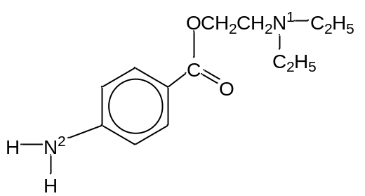  procaine
 |  | (i) | State and explain which of the N¹ or N² atom on the procaine molecule is more basic.
……………………………………………………………………………………………

……………………………………………………………………………………………

……………………………………………………………………………………………

……………………………………………………………………………………………

……………………………………………………………………………………………
 |  | (ii) | Draw the structural formula of the organic product(s) formed when Procaine reacts with the reagents in the table below.
Reagents | Organic product(s)
hot aqueous HCl

aqueous Br₂
in the dark

 |  |  | [4]
 |  |  | [Total: 10]
4 | (a) | Benzyl chloride, C₆H₅CH₂Cl, is widely used as an intermediate for manufacturing organic compounds including benzyl alcohol, benzyl cyanide and other benzyl compounds.  Benzyl cyanide can be produced via the reaction shown below:  C₆H₅CH₂Cl + CN– C₆H₅CH₂CN + Cl–  The kinetics of this reaction is determined by monitoring the change in the concentration of CN– with time.  For a two-step reaction, it was found that the rate equation for the above reaction is:  Rate = k[C₆H₅CH₂Cl]
 |  | (i) | For the above reaction, suggest a structure of the intermediate formed.
 |  | (ii) | Another compound with the formula C₆H₅CH₂CH₂Cl was also reacted with CN–. If this occurred via a similar two-step reaction, explain why the intermediate formed in a(i) is more stable than the intermediate of C₆H₅CH₂CH₂Cl.
……………………………………………………………………………………………

……………………………………………………………………………………………

……………………………………………………………………………………………

……………………………………………………………………………………………
 |  |  | [2]
 | (b) | Benzyl chloride can undergo different types of reaction depending on the reagent and conditions used. One of these reactions is used to convert benzyl chloride to 4-nitrobenzylchloride.  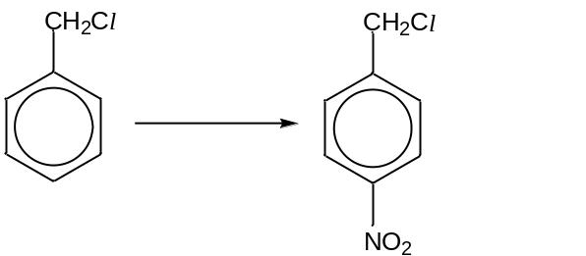  4-nitrobenzylchloride
 |  | State and describe the mechanism undergone during the conversion shown above.
 |  |  | [3]
 | (c) | When benzyl chloride is oxidised, benzoic acid is formed. You are provided with solid sodium benzoate and an aqueous solution of 0.10 mol dm⁻³ benzoic acid.  [Given M_{r} of sodium benzoate = 144.0; K_{a} of benzoic acid = 6.3 x 10⁻⁵ mol dm⁻³]
 |  | (i) | Calculate the concentration of sodium benzoate in g dm⁻³ in a buffer solution with a pH of 5.00.
 |  | (ii) | Suggest, with the aid of calculations, the mass of sodium benzoate needed to prepare 500 cm³ of a buffer solution with a pH of 5.00.
 |  |  | [3]

 | (d) | Benzoic acid can also be formed from benzene and it can further undergo several other reactions to produce other complex organic compounds. The synthetic route below can be used to produce crystalline solid X.  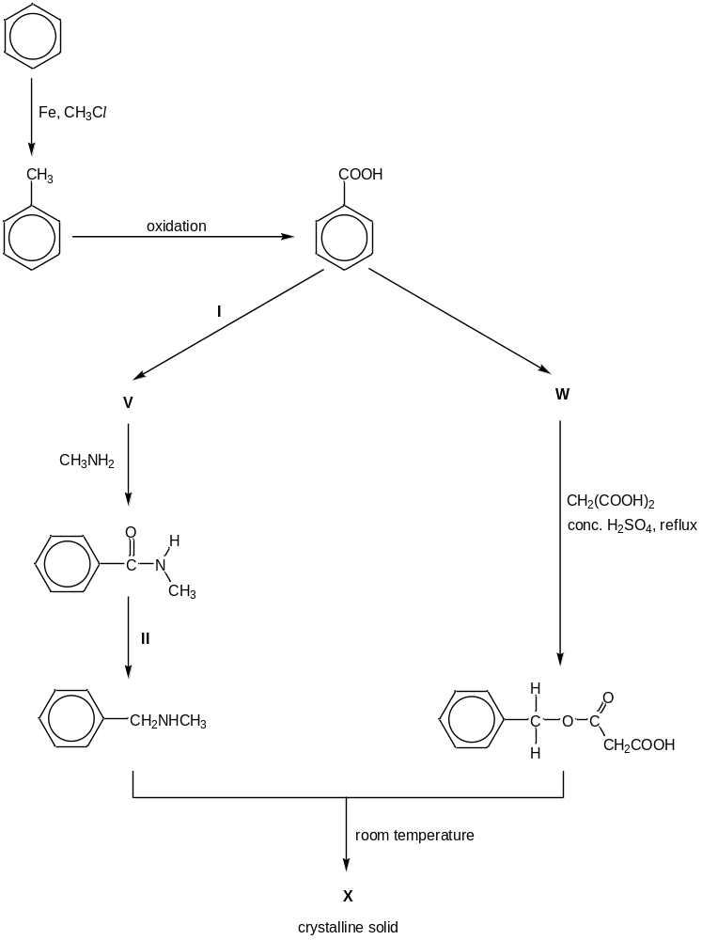
 |  | (i) | Draw the structures of V, W and X in the boxes provided.
V | W

X

 |  | (ii) | State the reagents and conditions required for reactions I and II.
reaction I

Reagent(s) : …………………………………………………….…………………

Conditions : …………………………………………………….…………………

reaction II

Reagent(s) : …………………………………………………….…………………

Conditions : …………………………………………………….…………………
 |  |  | [5]
 |  |  | [Total: 13]

5 | (a) | Phenolphthalein is one of the most common indicators used to determine the end point in a titration. When excess base is present at the end of an acid-base titration, the pink colour fades after the solution is left to stand in air for a while.  The structure of phenolphthalein is abbreviated as ‘Y’.  The fading of phenolphthalein in aqueous NaOH (above pH 10) can be studied to determine its rate equation. The concentration of phenolphthalein in solution can be followed by a spectrophotometer, which measures the concentration of Y²⁻ in terms of “Absorbance”. [Y²⁻] is taken to be directly proportional to the absorbance of the solution.  Fig. 5.1 shows the absorbance versus time graphs obtained for two different concentrations of NaOH, 0.200 mol dm⁻³ and 0.400 mol dm⁻³. In each case, only one drop of phenolphthalein was used.
  pH | form of phenolphthalein | colour
  below 8 | H₂Y | colourless
  8 to 10 | H₂Y + 2OH⁻ Y²⁻ + 2H₂O | pink
  above 10 | Y²⁻ + OH⁻ YOH³⁻ | colourless
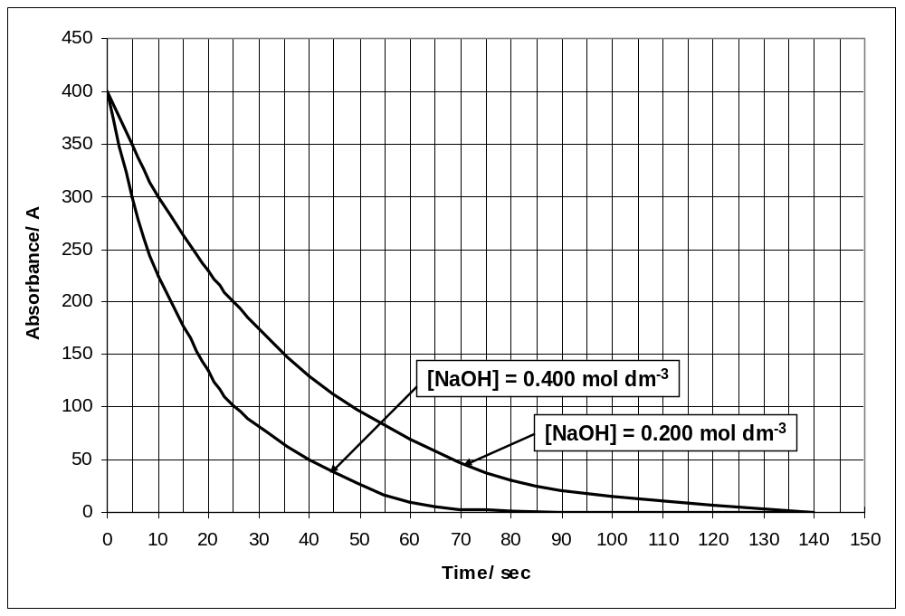
Fig. 5.1
 |  | Using the graphs in Fig. 5.1, find the order of reaction with respect to
 |  | (i) | NaOH
 |  | (ii) | Y²⁻
 |  | (iii) | Hence state the rate equation that describes the fading of phenolphthalein in aqueous NaOH above pH 10.
 |  |  | ……………………………………………………………………………………………
 |  |  | [5]
 | (b) | Warfarin is an anticoagulant used to treat blood clots. The structural formula of warfarin is shown below.  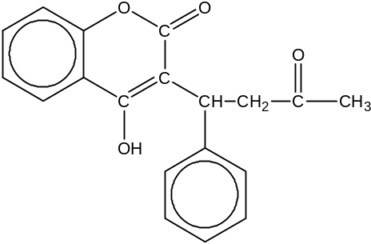  warfarin
 |  | Draw the structural formula of the organic product(s) formed when warfarin is reacted with the following reagents under the given conditions.
 |  | (i) | heat with aqueous I₂ and aqueous NaOH;
 |  | (ii) | LiAlH₄, dry ether.
 |  |  | [4]

 | (c) | 2-aminophenol and 4-aminophenol are positional isomers that have similar chemical properties but different physical properties. Their structures are shown below:  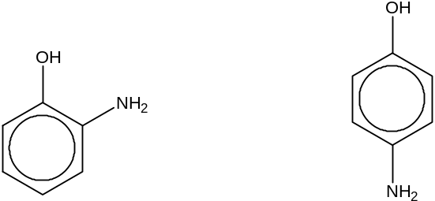  2-aminophenol 4-aminophenol  2-aminophenol was found to be less soluble in water than 4-aminophenol. Explain this phenomenon with reference to the bonding present.
.......................................................................................................................................

.......................................................................................................................................

.......................................................................................................................................
 |  |  | [1]
 | (d) | The presence of a lone pair of electrons on the nitrogen atom of an ammonia molecule allows it to function as a neutral ligand. One example in which ammonia acts as a ligand is shown below.  Co³⁺ + 6NH₃ [Co(NH₃)₆]³⁺  Using the Valence Shell Electron Pair Repulsion (VSEPR) Theory, explain the phenomenon that the H-N-H bond angle in ammonia when it is bound to Co³⁺ is 110, while that in an isolated ammonia molecule is about 107.
.......................................................................................................................................

.......................................................................................................................................

.......................................................................................................................................

.......................................................................................................................................

.......................................................................................................................................
 |  |  | [2]
 |  |  | [Total: 12]

6 | (a) | Electrosynthesis is the synthesis of chemical compounds in an electrochemical cell. The Kolbe electrolysis is one such example and is used to synthesise symmetrical or asymmetrical dimers derived from the salts of carboxylic acids.  An example of how an asymmetrical dimer can be produced is shown below:  electrolysis  R₁COO⁻ + R₂COO⁻ R₁-R₂ + carbon dioxide gas  asymmetrical  dimer  The above equation is not balanced.  In the laboratory, concentrated, aqueous sodium ethanoate is electrolysed in an alkaline medium between platinum electrodes via Kolbe electrolysis. Hydrogen gas is produced at the cathode. At the anode, a mixture of carbon dioxide and gas Z in the volume ratio of 2:1 are produced.
 |  | (i) | Write the half equation with state symbols for the reaction which occurs at the cathode.
 |  |  | Cathode: ………………………………………………………………………………..
 |  | (ii) | Suggest the identity of gas Z.
 |  |  | ……………………………………………………………………………………………
 |  | (iii) | Hence write the half equation with state symbols for the reaction which occurs at the anode.
 |  |  | Anode: …………………………………………………………………………………..
 |  | (iv) | In a separate electrosynthesis experiment, 5.13 g of a diatomic, oxidising gas produced at the anode was collected and transferred into a 2.0 dm³ vessel kept at 300 K and 9.0 x 10⁴ Nm⁻². Calculate the M_{r} of the gas and hence suggest a possible identity of the gas.
 |  | [5]

 | (b) | Ethene can be synthesised by Kolbe electrolysis. In the petrochemical industry, however, ethene is produced by steam cracking of ethane.  During steam cracking, ethane is cracked to yield ethene and hydrogen according to the following equation, where ethane is thermodynamically more stable than ethene.  CH₃CH₃(g) CH₂CH₂(g) + H₂(g)
 |  | Explain how the equilibrium position will be affected by
 |  | (i) | an increase in temperature;
……………………………………………………………………………………………

……………………………………………………………………………………………

……………………………………………………………………………………………
 |  | (ii) | a reduction in pressure.
……………………………………………………………………………………………

……………………………………………………………………………………………

……………………………………………………………………………………………
 |  |  | [4]
 | (c) | The ethene produced industrially can be used to produce phenylethene. Suggest a simple chemical test to distinguish between phenylethene and 1, 2-dichloroethane.
Reagent(s) : …………………………………………………….…………………

Conditions : …………………………………………………….…………………

 |  | Observations for phenylethene:
 |  | …………………………………………………………………………………………………
 |  | Observations for 1,2-dichloroethane:
 |  | …………………………………………………………………………………………………
 |  |  | [2]
 |  |  | [Total: 11]

BLANK PAGE

